1. Github Link: <https://github.com/Ariyune/Rate-Of-Fuel-Project.git>
2. Backend technologies that we used include PHP, because we wanted to integrate it with HTML, and also be able to use ajax calls to call the backend without refreshing the HTML page. It also allows for easy connection later on to the MySQL database, and allows us to perform validation, etc. in a manner similar to other languages we’ve worked with, like javascript.
3. The code coverage report can be found as an HTML file titled index.html inside the html.rar file I have provided. Just extract it out, and look for the index.html.

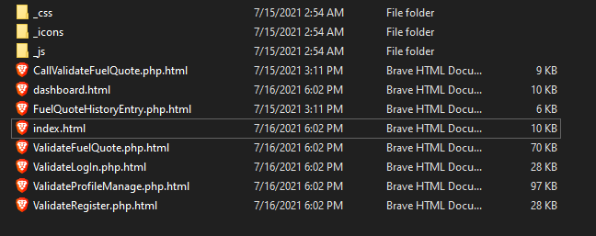

The code coverage report should appear like so, upon opening the index.html file:   
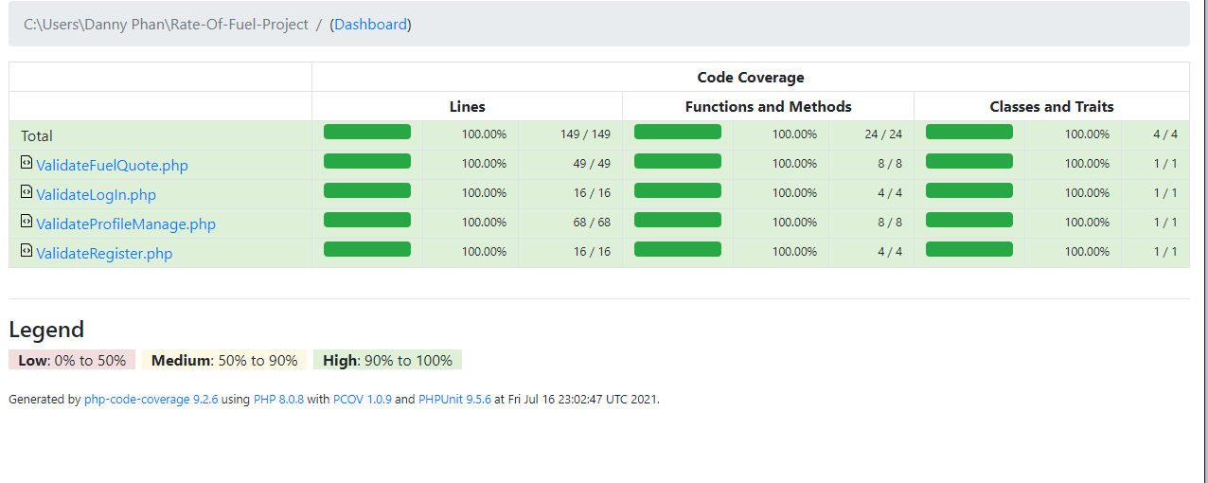  
The way we ran it is simple. Our code contains classes for each portion, such as login, registration, profile management, and fuel quote form. We have functions that validate the inputs (empty, wrong characters, etc.). To do code coverage, we ran the unit tests on these functions, and verify they gave the right output. It should be 100% from what we determined and ran, as we covered all the possibilities for validation using the backend.

1. Like before, each person continued working on their portion, only extending the backend now for Assignment 3. Dong Nguyen worked on the login/registration. Carlos worked on the profile management/display. Danny Phan worked on the fuel quote form. All members worked on the respective validations for their forms. Danny Phan was responsible mostly for providing the code coverage report and unit tests, although assistance was given through the formatting of the modules by other members to ease the writing of the unit tests.